
U.S.A. RECALL CAMPAIGN No. 57
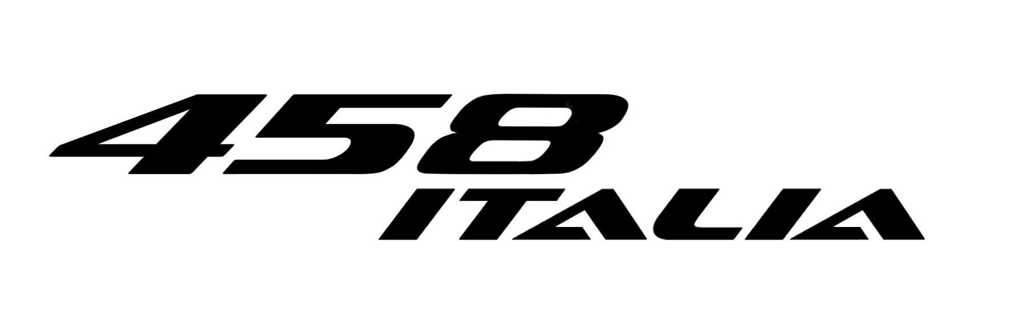







Replacing the Driver’s Side Air Bag Module.
TECHNICAL INSTRUCTIONS

Please read all instructions before performing this campaign.

The procedure required for this RECALL CAMPAIGN consists of replacing the Driver’s Side Air Bag Module.

This procedure is necessary to ensure complete conformity with applicable safety standards, namely FMVSS 208 (USA).

- Procedure

- IMPORTANT -

Open an ROL in the event of any problem encountered during the procedures described below.

- IMPORTANT -

Once the work has been carried out, open a ROL and attach the photographic documentation required and the “Replacement of driver side air bag module traceability form” on page 9, which has been fully completed.

- IMPORTANT -
- Use safety goggles when handling closed Air bag modules.
- Always place the air bag module down with the leather-upholstered side facing upwards.
- NEVER place anything on the leather-upholstered side of the air bag module.
- Always handle the air bag module with the leather-upholstered side away from the body.

The RECALL CAMPAIGN procedure described herein must be performed exactly as indicated by the following instructions:

- IMPORTANT -
DO NOT damage or discard the packaging of the new replacement airbag since it must be reused to package the airbag that has been removed from the vehicle.

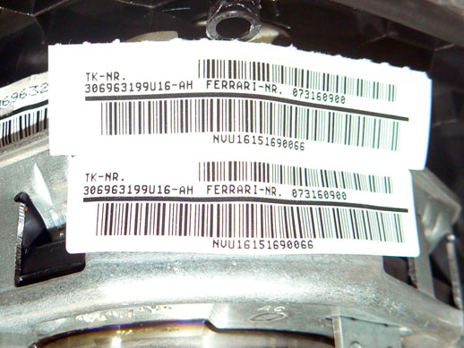
- Remove the label with the airbag ID details shown in the photograph from the new airbag and attach it to the special space on the “Replacement of driver side airbag module traceability form” attached on page 5, which must first be printed – Fig. 1.
Fig. 1

  - Remove the driver’s side air bag module (as described in paragraph F4.02 step 1 of the Workshop Manual).

  - Install the NEW driver’s side air bag module (as described in paragraph F4.02 step 2 of the Workshop Manual).

  - Connect the DEIS diagnostic tester to the diagnostic socket in the vehicle and perform the air bag control unit cycle 10 NAB Complete Cycle.

  - Ensure that the cycle is completed successfully – Fig. 2.

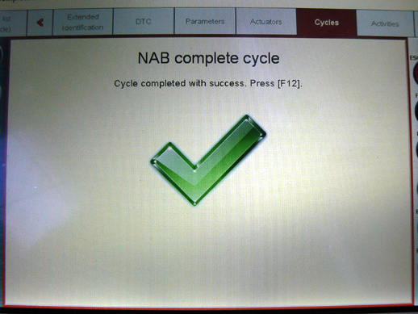
Fig. 2

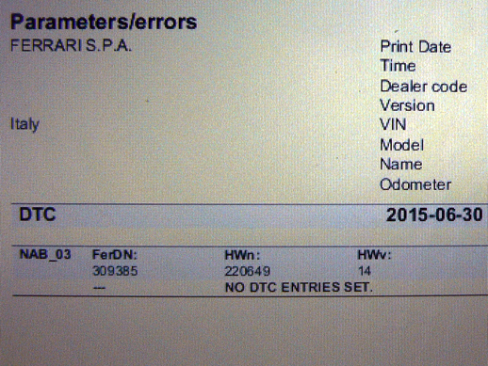
  - Access the “DTC” area of the DEIS Tester relative to the “NAB” air bag ECU, select “Save”, “Preview” and “Print” in the sequence given and check that there are no active errors in the ECU memory – Fig. 3.
Fig. 3
Note: If errors are present, attach the file generated to the ROL.

  - Perform SCAN OUT with the DEIS tester.

  - Complete all parts of the form attached on page 9 and attach it to the ROL, together with the file created in point 7 if errors are present.

- IMPORTANT -
The driver’s side air bag modules that have been removed must be packaged
using the original packaging of the replacement air bag with the vehicle
serial number written on the box. The old Air Bags will be collected from your
premises directly by the component supplier.

Please note that, once the driver’s side air bag module has been replaced, as indicated in Recall Campaign No. 57, you must fully complete this form and take the required photograph so that the Ferrari database can be updated.
 | Replacement of driver side airbag module  traceability form | Page 01 of 01
 | Model | Updated on
 |  | July 2015
Customer:
Chassis number:
Date:
Km/mi:
NOTES:
NEW DRIVER’S SIDE AIR BAG MODULE ID LABEL
(attach the label to the space below)

Take a photograph of the ID label on the replaced driver’s side air bag module
and attach it to the ROL.
After fully completing this form, attach it to the ROL together
with the photographic documentation.
Task performed by (Dealer):
Technical Manager:
Name: |  |  | Surname:
 | (block letters) |  |  | (block letters)
Company stamp
 |  |  | Signature
 |  |  | Date:

