Disconnect the vehicles’ battery Positive and Negative, disconnect any House battery(s) Positive and Negative, if equipped with a generator ensure it is off and lastly, ensure the vehicle is disconnected from shore power. Block any tires/wheels to prevent the vehicle from rolling. Failure to do so may result in electrocution, fire or other personal injury, property damage and/or death.

STEP 1: LOCATE THE 7-WAY BARGMEN PLUG JUNCTION BOX LOCATED ON THE FIFTH-WHEEL HITCH OR NEAR THE FIFTH-WHEEL HITCH;

STEP 2: REMOVE THE COVER OF THE JUNCTION BOX;

STEP 3: INSPECT THE WIRING FOR ANY DAMAGE;

STEP 4: IF THERE IS WIRE DAMAGE, LOOSE CONNECTORS OR ANYTHING THAT MAY LEAD TO A ELECTRICAL FAILURE PRESENT IN THE JUNCTION BOX, FIX THOSE CONCERNS AT THIS TIME;

STEP 5: CAREFULLY REMOVE THE SELF-TAPPING FASTENER THAT MOUNTS THE JUNCTION BOX TO THE FIFH-WHEEL HITCH OR NEAR THE FIFTH-WHEEL HITCH;

STEP 6: RELOCATE THE JUNCTION BOX UP INTO THE HITCH BOX AS SHOWN IN FIGURE 1

FIGURE 1
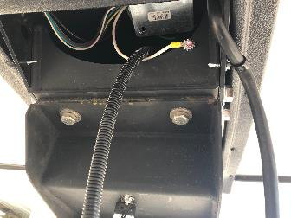

STEP 7: RELOCATE THE BREAKAWAY SWITCH TO THE LOCATION SHOWN IN FIGURE 2

FIGURE 2
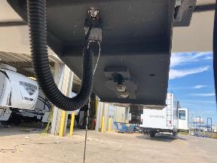

STEP 8: TEST 7-WAY BARGEMEN PLUG AND BREAKAWAY SWITCH FOR PROPER FUNCTIONALITY;

STEP 9: IF TESTING IS SUCCESSFUL, CLAIM THE REPAIR CODES AS LISTED IN THE NOTIFICATION.

